**Digital Image Processing**

**Title: Introduction to python for Image Processing**

**Objectives:** Python for image processing

**Tools Used:** python IDLE/Jupyter

**Procedure:** Open idle and perform the following tasks

**Task 1:**

**Load image and display. Convert to gray scale and display. Write the grayscale image to another directory with different extension.**

**Code:**

import os  
import cv2  
  
oldpath = r'C:\Users\Naeem\Desktop\Jahanzeb\DIP\DIP Lab\4\1.JPG'  
newpath = r'E:\New folder'  
  
img = cv2.imread(oldpath, cv2.IMREAD_COLOR)  
img2 = cv2.cvtColor(img, cv2.COLOR_BGR2GRAY)  
  
  
cv2.imshow('sed boi catto', img)  
cv2.imshow('gray catto', img2)  
  
os.chdir(newpath)  
cv2.imwrite('gray catto.png', img2)  
  
cv2.waitKey(0)

**Screenshot:**

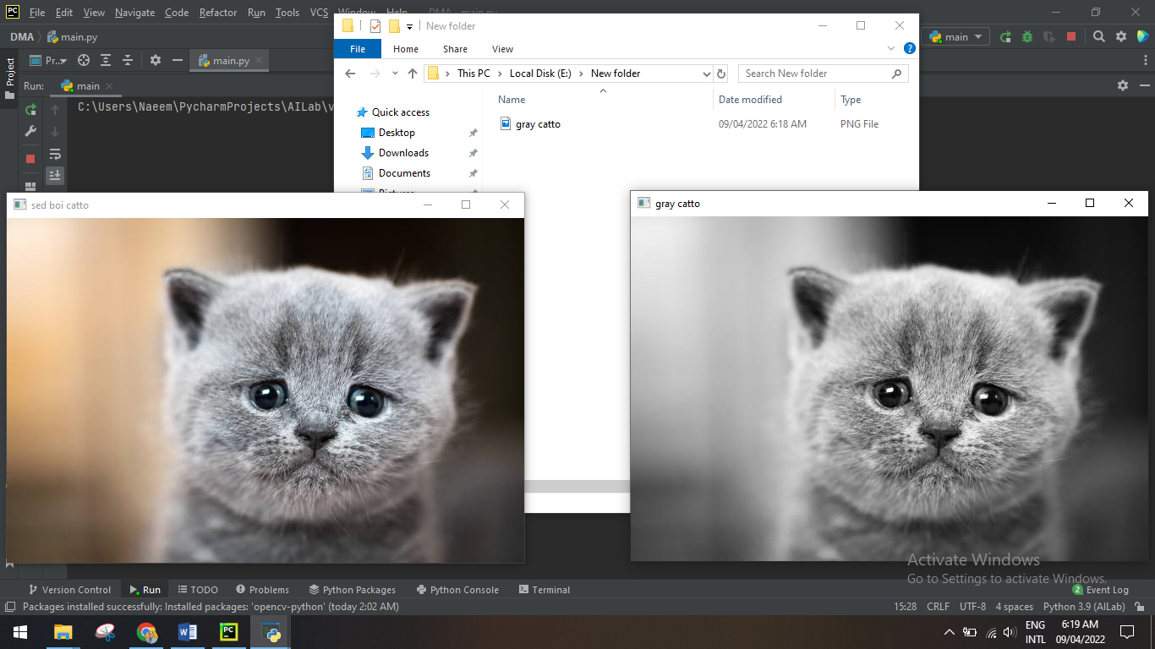

**Task 2:**

**Binarize any image through your own logic, (without using the given library function). Loop through the pixel values as shown in lab. Ask the value of threshold in binarization from user.**

**Code:**

import os  
import cv2  
  
path = r'C:\Users\Naeem\Desktop\Jahanzeb\DIP\DIP Lab\4\1.JPG'  
  
img = cv2.imread(path, cv2.IMREAD_COLOR)  
img2 = cv2.cvtColor(img, cv2.COLOR_BGR2GRAY)  
  
size = img2.shape  
  
res = img2  
  
T = int(input('Input threshold: '))  
  
for i in range(size[0]):  
 for j in range(size[1]):  
 value = int(img2[i][j])  
  
 if value >= T:  
 res[i][j] = 255  
 else:  
 res[i][j] = 0  
  
  
cv2.imshow('sed boi catto', img)  
cv2.imshow('binarized catto', res)  
  
  
cv2.waitKey(0)

**Screenshot:**

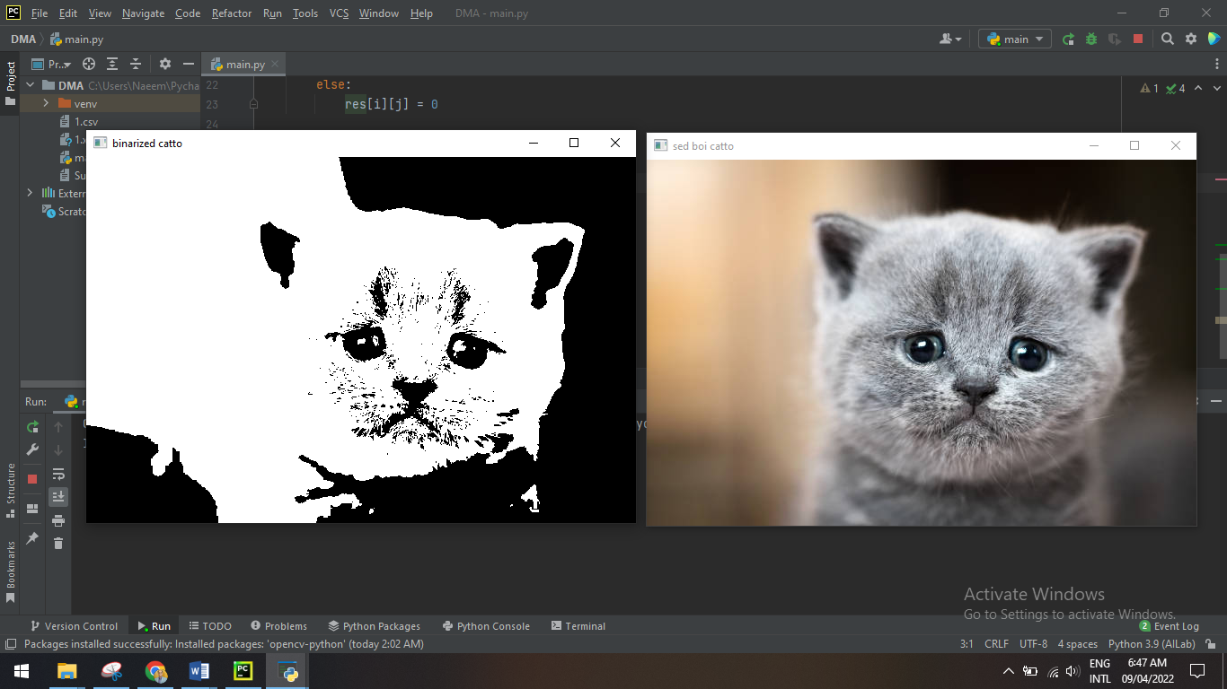

**Task 3:**

**Gray scale any color image using the average method, write code from scratch. (Without using the given library function).**

**Code:**

import os  
import cv2  
  
path = r'C:\Users\Naeem\Desktop\Jahanzeb\DIP\DIP Lab\4\1.JPG'  
  
img = cv2.imread(path, cv2.IMREAD_COLOR)  
size = img.shape  
  
res = img  
  
for i in range(size[0]):  
 for j in range(size[1]):  
 value = sum(img[i][j])  
 res[i][j] = value / 3  
  
cv2.imshow('grayscale catto', res)  
  
  
cv2.waitKey(0)

**Screenshot:**

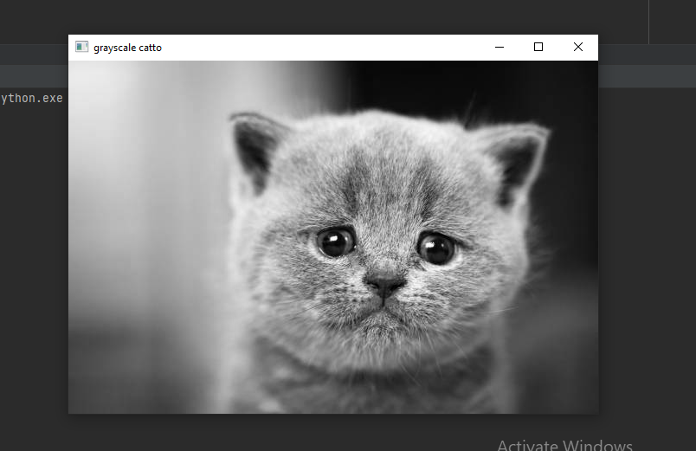

**Task 4:**

**Open webcam and perform gray scaling and binarizing on the video frames, you can use opencv functions for gray scale and binarization.**

**Code:**

**(for grayscaling)**

import cv2  
  
cap = cv2.VideoCapture(1)  
  
if not cap.isOpened():  
 raise IOError("Cannot open webcam")  
  
while True:  
 ret, frame = cap.read()  
 cv2.imshow('original', frame)  
  
 gray = cv2.cvtColor(frame,cv2.COLOR_BGR2GRAY)  
 cv2.imshow('gray', gray)  
  
  
 c = cv2.waitKey(1)  
 if c == 27:  
 break

**(for binarizing)**

import cv2  
  
cap = cv2.VideoCapture(1)  
  
if not cap.isOpened():  
 raise IOError("Cannot open webcam")  
  
while True:  
 ret, frame = cap.read()  
 cv2.imshow('original', frame)  
  
 gray = cv2.cvtColor(frame,cv2.COLOR_BGR2GRAY)  
 ret2, bw = cv2.threshold(gray,100,255, cv2.THRESH_BINARY)  
 cv2.imshow('gray', bw)  
  
  
 c = cv2.waitKey(1)  
 if c == 27:  
 break